Js Files(Jsmeter):-

- Vaistreet\controllers\api

There are 12 functions in this file. Function with the largest signature take 1 arguments, while the median is 0.Largest function has 12 statements in it, while the median is 4.The most complex function has a cyclomatic complexity value of 2 while the median is 1.5.

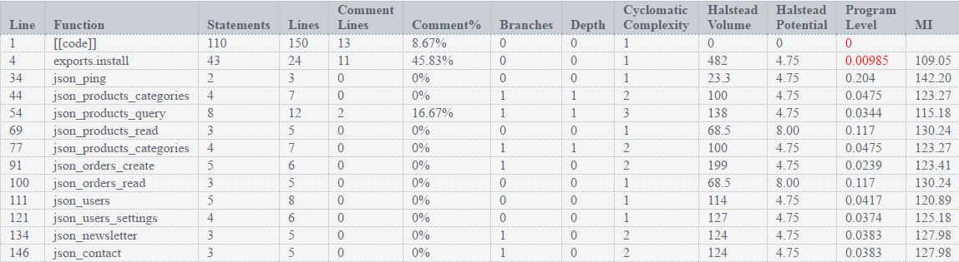

- Vaistreet\controllers\default

There are 20 functions in this file. Function with the largest signature take 3 arguments, while the median is 1.Largest function has 9 statements in it, while the median is 2.The most complex function has a cyclomatic complexity value of 4 while the median is 1.

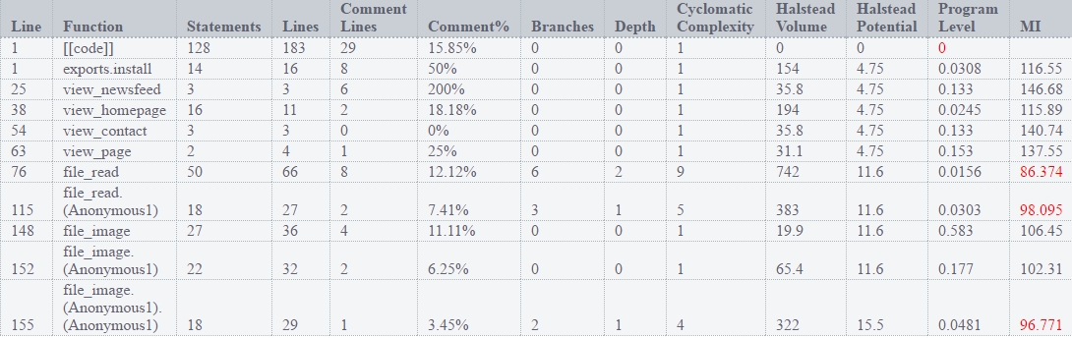

- Vaistreet\controllers\manager

There are 19 functions in this file. Function with the largest signature take 3 arguments, while the median is 0.Largest function has 47 statements in it, while the median is 2.The most complex function has a cyclomatic complexity value of 5 while the median is 1.

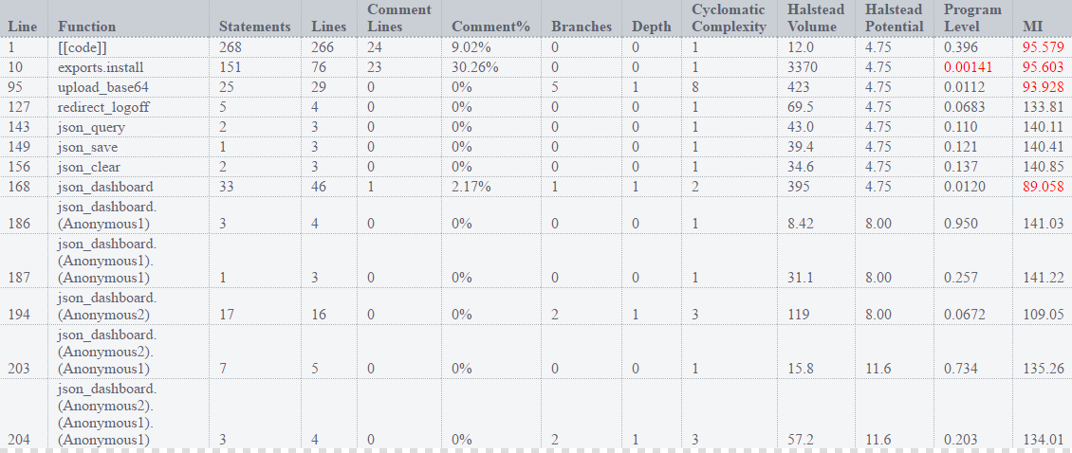

- Vaistreet\controllers\eshop

There are 10 functions in this file. Function with the largest signature take 2 arguments, while the median is 0. Largest function has 12 statements in it, while the median is 4.The most complex function has a cyclomatic complexity value of 5 while the median is 1.

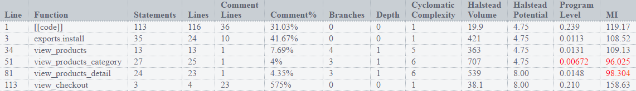

- Vaistreet\controllers\oauth2

There are 5 functions in this file. Function with the largest signature take 2 arguments, while the median is 1.Largest function has 29 statements in it, while the median is 11.The most complex function has a cyclomatic complexity value of 21 while the median is 3.

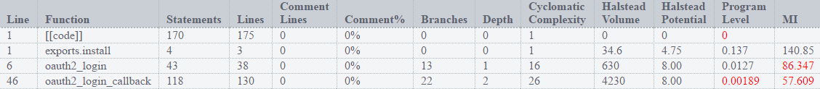

- Vaistreet\definitions\auth

There are 2 functions in this file. Function with the largest signature take 2 arguments, while the median is 1.5.Largest function has 13 statements in it, while the median is 7.The most complex function has a cyclomatic complexity value of 5 while the median is 3.5.



- Vaistreet\definitions\helpers

There are 3 functions in this file.Function with the largest signature take 2 arguments, while the median is 2.Largest function has 8 statements in it, while the median is 2.The most complex function has a cyclomatic complexity value of 3 while the median is 3.

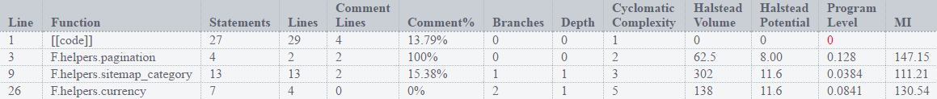

- Vaistreet\definitions\settings

There are 2 functions in this file.Function with the largest signature take 4 arguments, while the median is 3.Largest function has 4 statements in it, while the median is 3.5.The most complex function has a cyclomatic complexity value of 2 while the median is 1.5.



- Vaistreet\Models\contact

There are 2 functions in this file.Function with the largest signature take 4 arguments, while the median is 2.5.Largest function has 10 statements in it, while the median is 9.The most complex function has a cyclomatic complexity value of 2 while the median is 1.5.

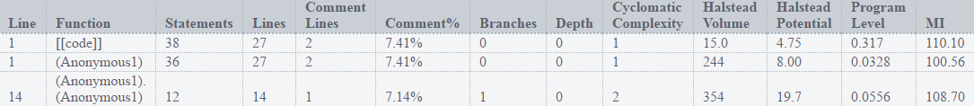

- Vaistreet\Models\newsletter

There are 6 functions in this file. Function with the largest signature take 4 arguments, while the median is 3.5.Largest function has 7 statements in it, while the median is 2.The most complex function has a cyclomatic complexity value of 3 while the median is 1.

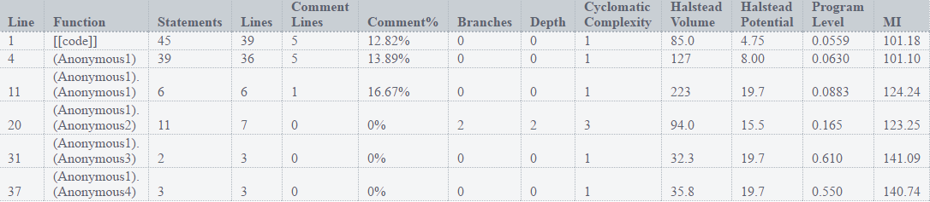

- Vaistreet\Models\settings

There are 13 functions in this file.Function with the largest signature take 4 arguments, while the median is 2.Largest function has 38 statements in it, while the median is 3.The most complex function has a cyclomatic complexity value of 10 while the median is 1.

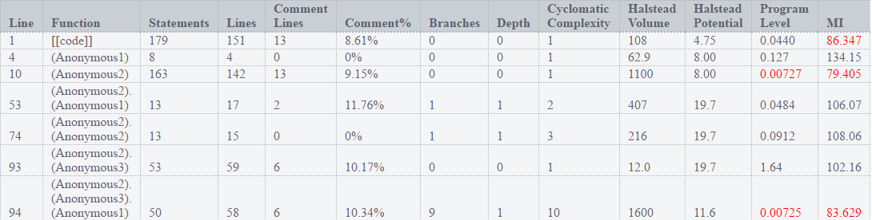

- Vaistreet\Models\users

There are 32 functions in this file. Function with the largest signature take 4 arguments, while the median is 2.Largest function has 24 statements in it, while the median is 3.5.The most complex function has a cyclomatic complexity value of 6 while the median is 1.

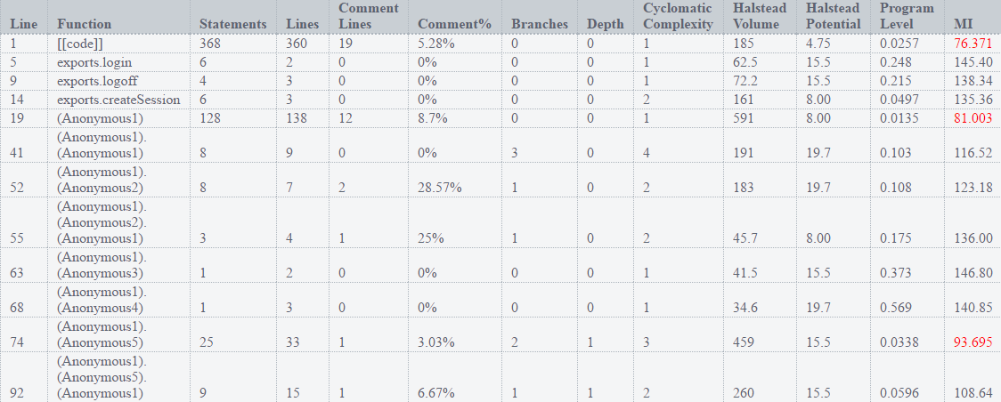

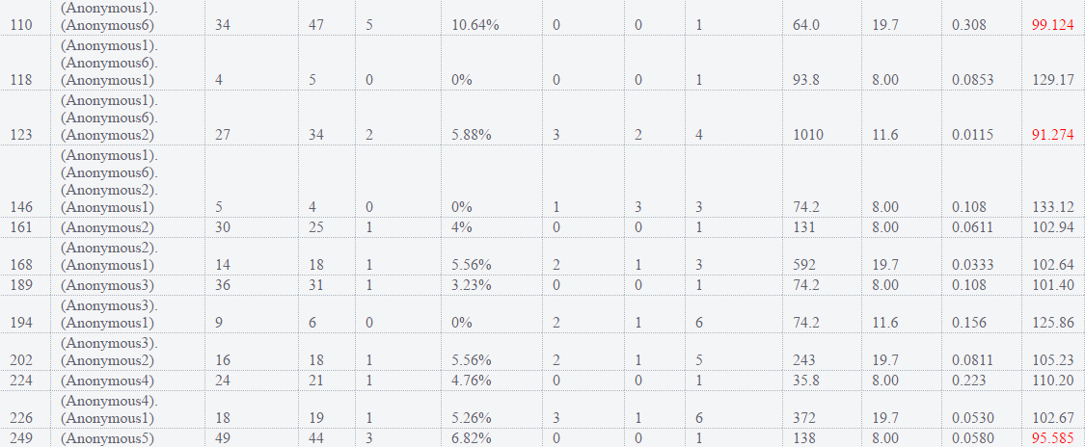

- Vaistreet\modules\oauth2

There are 36 functions in this file. Function with the largest signature take 6 arguments, while the median is 2.Largest function has 15 statements in it, while the median is 3.The most complex function has a cyclomatic complexity value of 11 while the median is 1.

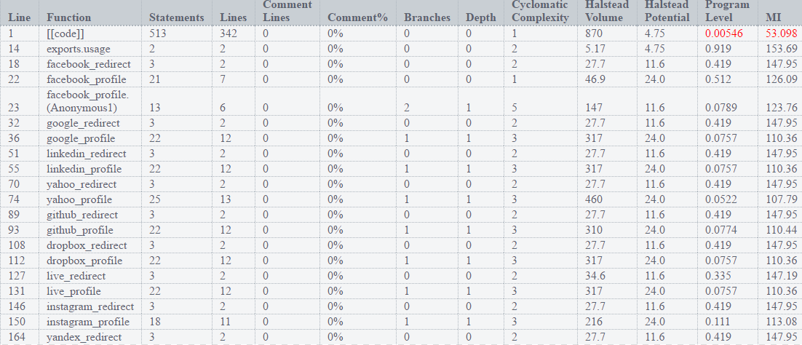

- Vaistreet\public\js\manager

There are 24 functions in this file. Function with the largest signature take 2 arguments, while the median is 0.Largest function has 5 statements in it, while the median is 1.The most complex function has a cyclomatic complexity value of 3 while the median is 1.

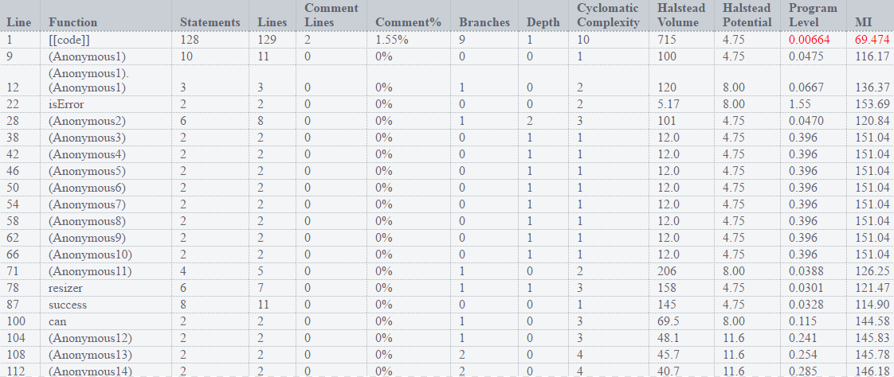

- Vaistreet\public\js\default

There are 28 functions in this file. Function with the largest signature take 3 arguments, while the median is 0.Largest function has 14 statements in it, while the median is 3.The most complex function has a cyclomatic complexity value of 8 while the median is 1.5.

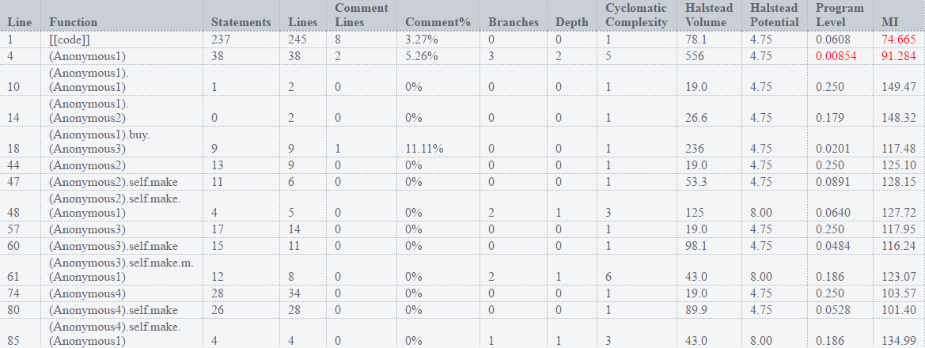

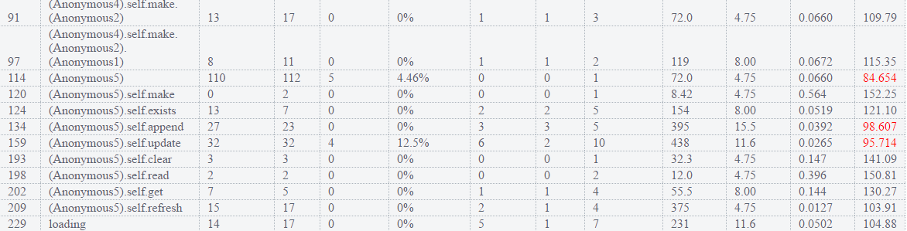

Vaistreet\themes\default\index

There is only one function in this file. It takes no arguments .This function contains 2 statements. Cyclomatic complexity number for this function is 1.



Vaistreet\themes\default\views

There are 5 functions in this file. Function with the largest signature take 1 arguments, while the median is 1.Largest function has 6 statements in it, while the median is 2.The most complex function has a cyclomatic complexity value of 1 while the median is 1.

